- Given a point R, there exists a set of points in the same plane such that each point is the same distance from R. This set of points defines what figure?
- Circle
- Ellipse
- Parabola
- Square

- What figure is defined as the set of all the points in a plane that are the same distance from a given point on the same plane?
- a circle
- a square
- a line parallel to a given line
- the perpendicular bisector of a segment

- The transformation (x’, y’) = (x + 2, y – 3) is applied to figure PQRS.
Use graph paper to create P'Q'R'S.
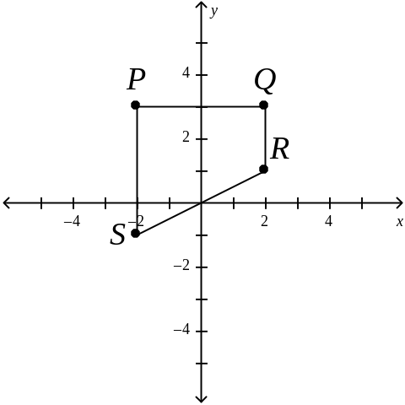
- A regular hexagon with three congruent rhombus-shaped sections is shown in the figure.

What is the smallest rotation clockwise about the center of the figure that will carry the entire figure onto itself?
- 60°
- 90°
- 120°
- 180°

- Regular octagon STUVWXYZ is rotated 135 degrees clockwise around its center.
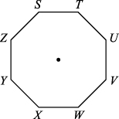
Vertex X is carried onto which vertex after the rotation?
- S
- U
- W
- Z

- Point P has image P', where P and P' are the endpoints of an arc of N degrees along a circle centered at O with radius OP. Which transformation is described?
- reflection over OP
- translation along vector OP
- rotation of N degrees centered at O
- dilation with a scale factor of N centered at O

- Triangle RST is translated 5 units left and 3 units down, then reflected over the line

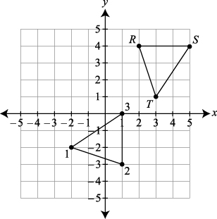
Angle 1 is congruent to angle _______.

- Which transformations applied to polygon I would produce polygon II?
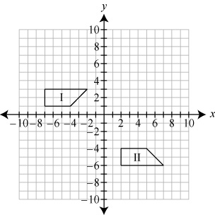
- Translate 9 units right and 7 units down.
- Reflect across the y-axis and translate 7 units down.
- Reflect across the x-axis and translate 9 units right and 3 units down.
- Reflect across the x-axis, reflect across the y-axis, and translate 3 units down.

- The circle shown has its center located at the point (5, 4).
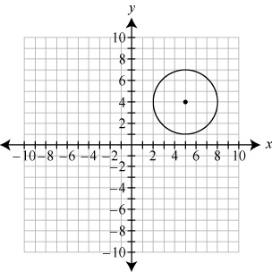
The circle is reflected over the line y = –x. What are the coordinates of the center of the image?
- (-5, 4)
- (-4, -5)
- (4, 5)
- (5, – 4)

- A point P(7, 4) is translated 3 units down and 1 unit right. The image P′ of P is then rotated 180° clockwise around the origin, resulting in point P″. What are the coordinates of P″?
- (-8, -1)
- (-4, -5)
- (1, -8)
- (5, -4)

- Parallelogram WXYZ is shown, including diagonal .
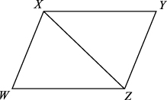
Which single, rigid motion could be applied to ∆WXZ in order to show that ∆WXZ ∆YZX?
- Reflection across
- Reflection across
- rotation about the midpoint of
- rotation about the midpoint of

- Two congruent triangles are shown on the coordinate plane.

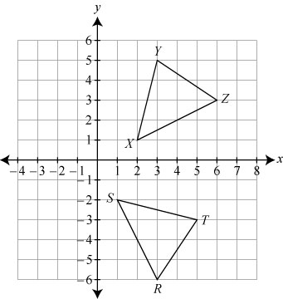

Which congruency statement is true?
- If ∆XYZ is reflected over the x-axis, its image is ∆X’Y’Z’. If m∠X = 50°, m∠Y = 70°, then m∠Z′ = ?
- 50°
- 60°
- 70°
- 120°

- For the figure shown below, and .
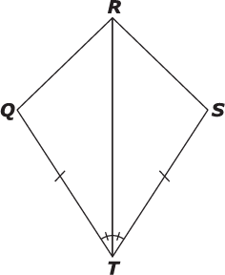
Which transformation of ∆RTS is implied to create ∆RTQ, proving ∆RTS ∆RTQ?
- a reflection of ∆RTS over segment TR
- a rotation of ∆RTS counterclockwise about T, with an angle measure of 2 times the measure of angle STR
- a horizontal translation of ∆RTS by the distance from S to T
- insufficient information given to prove any transformation of ∆RTS has image ∆RTQ

- Three triangles are shown.
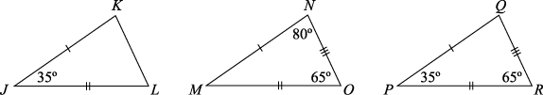
Select all statements that must be true.
- There is a rigid motion that maps ∆JKL to ∆MNO.
- There is no rigid motion that maps ∆JKL to ∆PQR.
- ∆JKL and ∆PQR can be proved to be congruent.
- ∠MNO can be proved to be congruent to ∠PQR.
- ∠JLK has measure 55°.

- An incomplete proof is shown.
Given: W is the midpoint of , W is on , and .
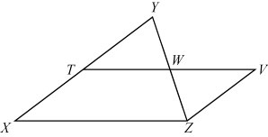
Prove:
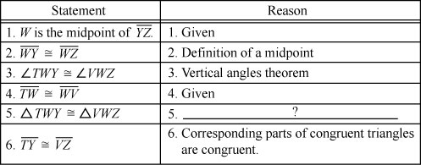

What is the reason that justifies Statement 5?
- side-side-side
- side-angle-side
- angle-angle-side
- angle-side-angle

- The following drawing and statements are used in a proof.
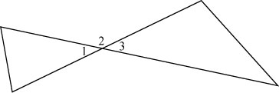

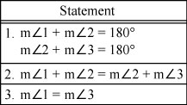
The statements above can be used in the order given to prove what geometric theorem?
- Vertical angles are congruent.
- Supplementary angles are congruent.
- Two angles that form a linear pair are supplementary.
- The sum of the measures of the angles of a triangle is 180°.

- The figure shows parallel lines m and n cut by transversals p and q.
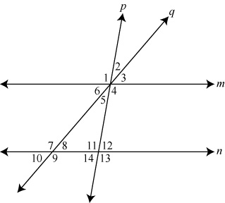
Identify the equal values.

- In this diagram, m∠1 = m∠2 = m∠3 = m∠4 and KL = ⅔(MN).
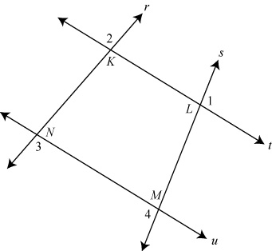
Using _______ can be proved to be parallel to .
Quadrilateral KLMN is a _______.

- Figure RSTU is a parallelogram.
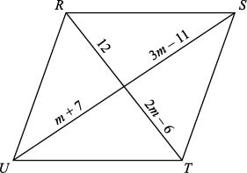
What is the length of , in units?

- The rhombus WXYZ has diagonals that meet at point O.

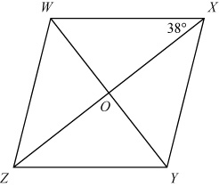

What is the measure of ∠XWO?
- 38°
- 52°
- 90°
- 142°

- Henry is bisecting ∠RST and has created points W, X, and Y so that and .
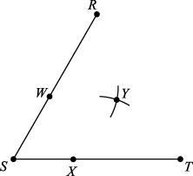

Which two points are on the ray that bisects ∠RST?
A. S and Y
B. R and T
C. W and X
D. X and Y
23. A rectangle is dilated on the coordinate plane. The area of the dilated rectangle is 16 times the
area of the original rectangle. What is the scale factor of the dilation?

24. Quadrilateral A(-2,4), B(4,6), C(4,2), D(2,-2) is on the coordinate grid. The quadrilateral is dilated by a factor of 1.5 about the origin to create A’B’C’D’. Use a graph to create A’B’C’D’.

25. Triangle RST is a dilation of triangle KLM with the center of dilation at point C, as shown.
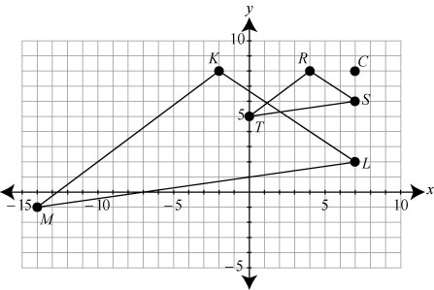
What is the scale factor of this dilation?
- 1
6
- ¼
- ⅓
- 3
7

26. There are two rectangles.
- Rectangle WXYZ has a length of 12.5 inches and a width of 6.25 inches.
- For rectangle RSTU, the length is twice its width.
Which statement will always be true of the relationship between rectangle WXYZ and rectangle RSTU?

  - Rectangle WXYZ and rectangle RSTU are similar.
  - The area of rectangle RSTU is twice the area of rectangle WXYZ.
  - The areas of rectangle WXYZ and rectangle RSTU are the same.
  - Rectangle WXYZ and rectangle RSTU are congruent.

27. Pentagon ABCDE is similar to pentagon RSTUV.
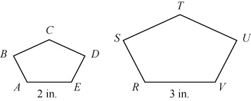
Which must be true of the measure of angle A?
- It is⅔ the measure of angle V.
- It is congruent to the measure of angle E.
- It is congruent to the measure of angle R.
- It is smaller than any angle found in RSTUV.

28. Triangle KLM is shown.
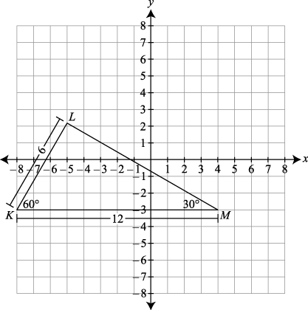
Triangle KLM is dilated by a factor of ⅔ and translated 2 units to the right. Which statement about the image ∆K’L’M’ is true?
- K′L′ = 6 units
- K′M′ = 14 units
- m∠M′ = 30°
- m∠K′ = 40°
29. Which statement would prove there is a similarity transformation between two triangles?
A. If two sides of one triangle are congruent to two sides of another triangle, then the triangles are similar.
B. If two sides of one triangle are proportional to two sides of another triangle, then the triangles are similar.
C. If two angles of one triangle are congruent to two angles of another triangle, the two triangles are similar.
D. If two angles of one triangle are proportional to two angles of another triangle, then the triangles are similar.

30. Mr. Smith wants to find the length, l, of a pond. He knows the distances shown in the diagram.
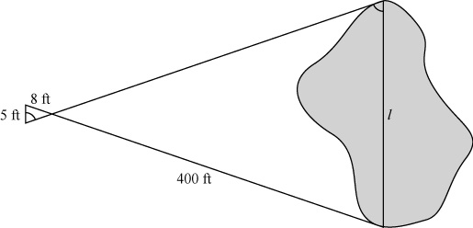
What is the length, in feet, of the pond?

