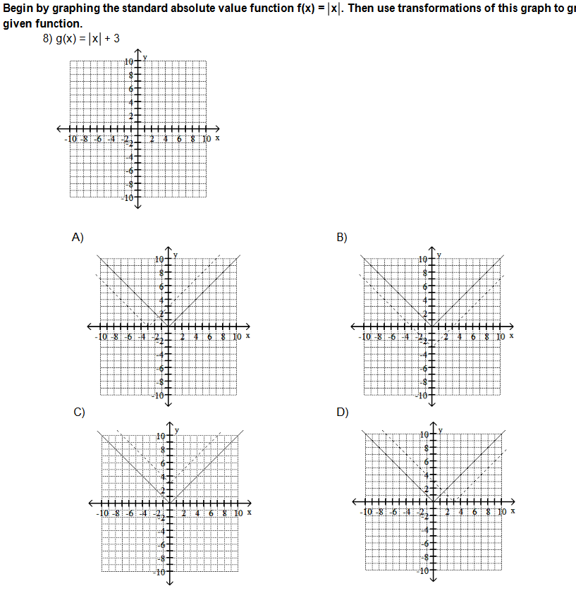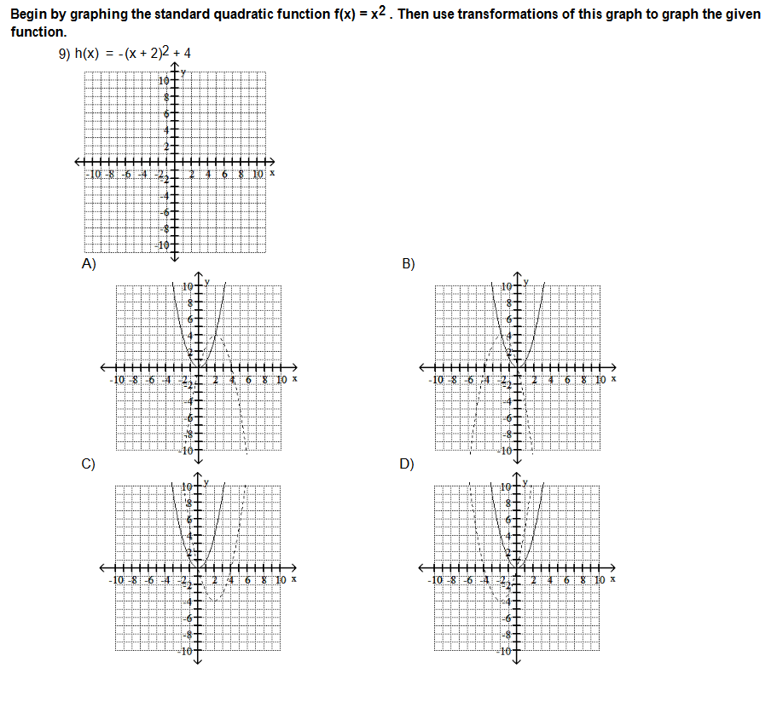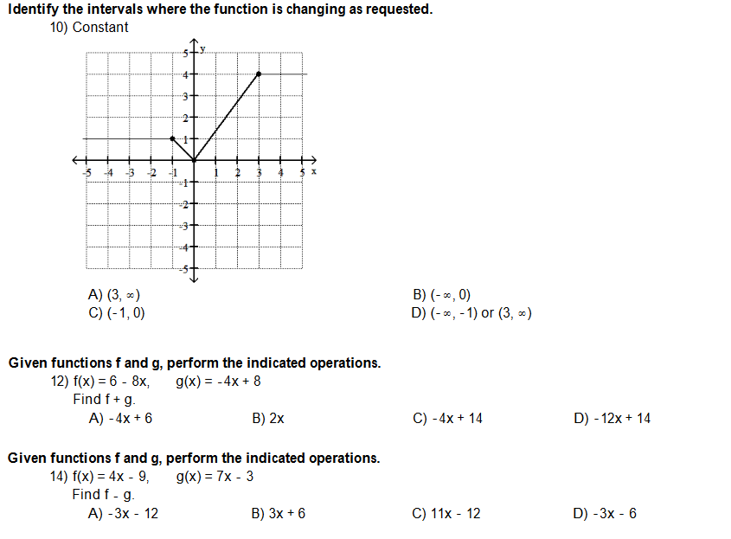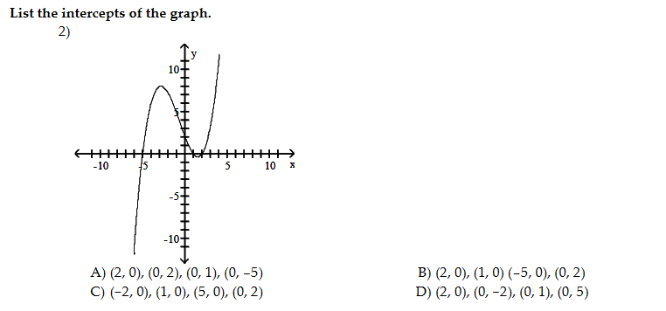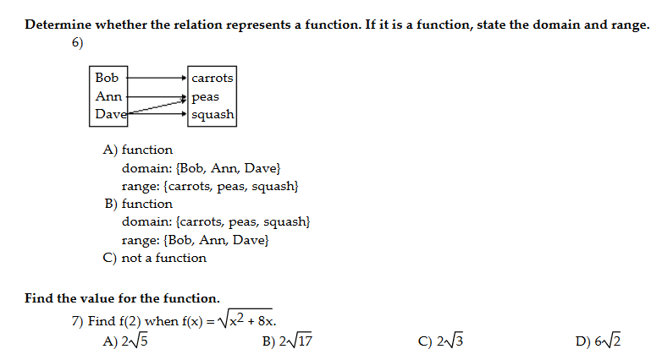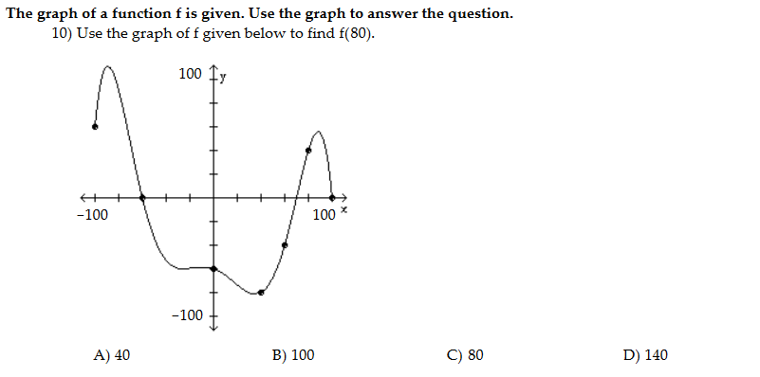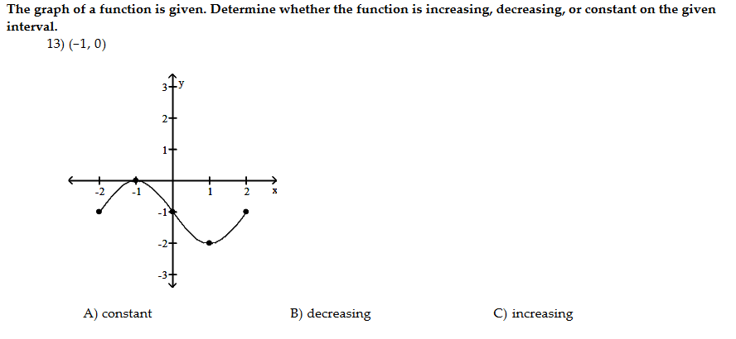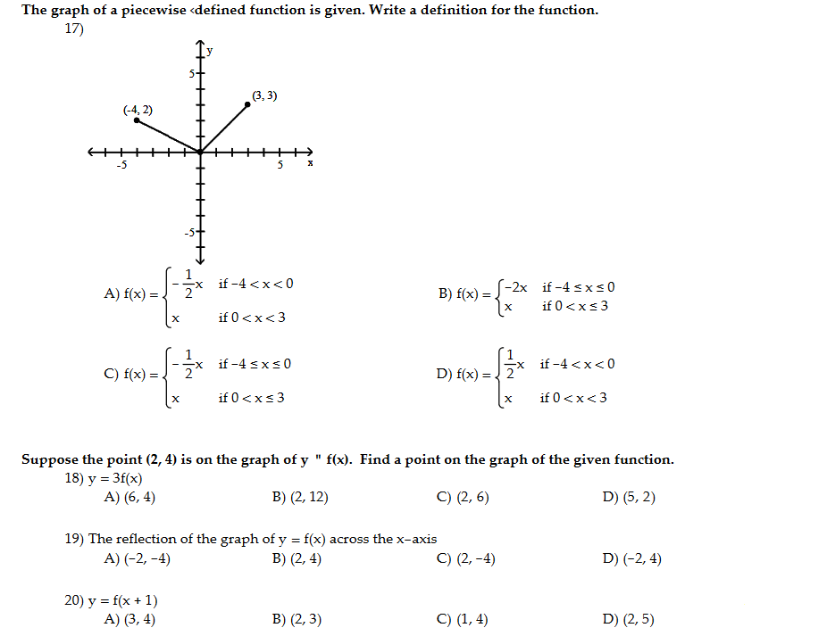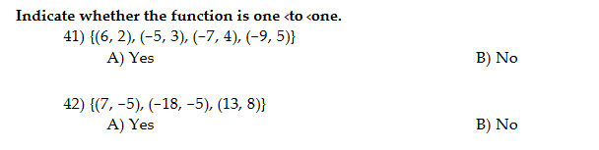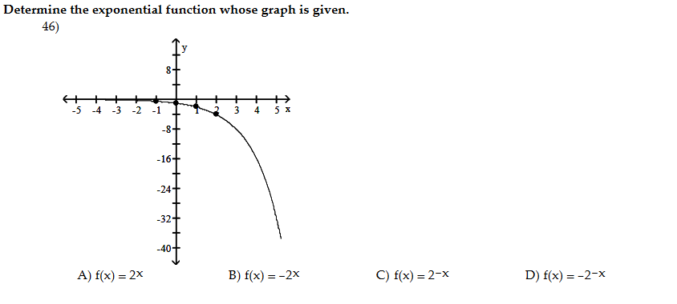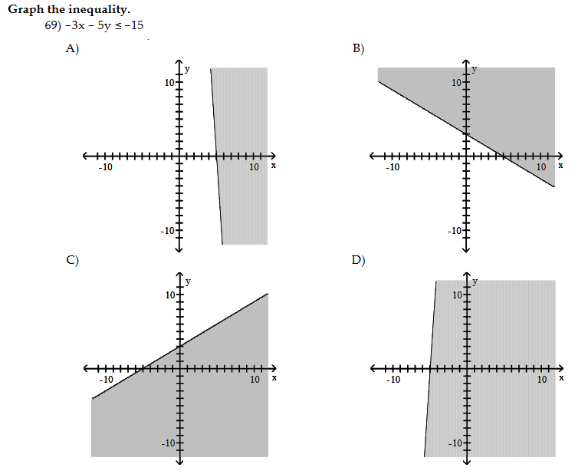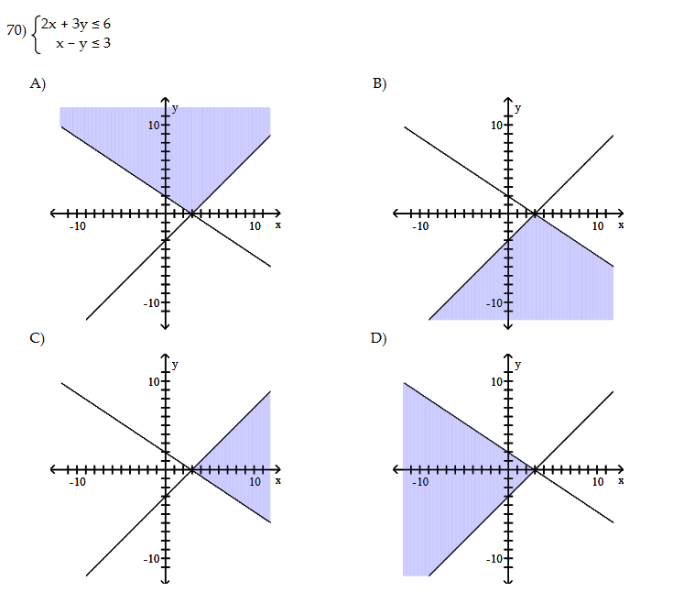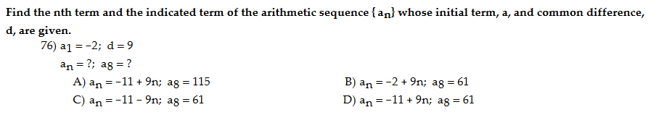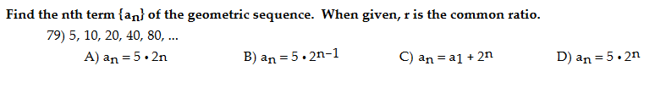

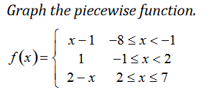



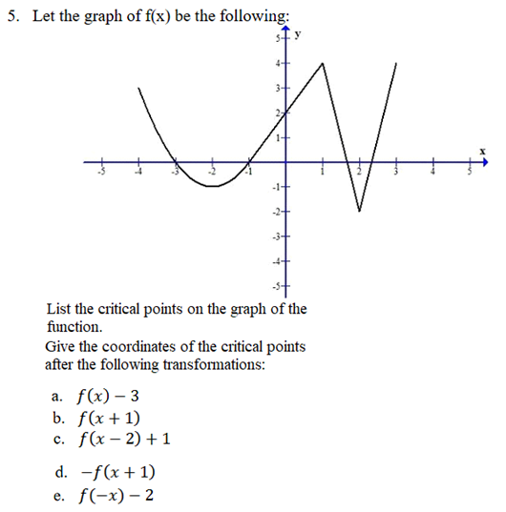





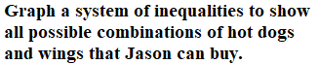

A mountain in Butler County is eroding and losing elevation at a rate of 5% every millennium. If the current elevation is 1,200 meters, how tall will the mountain be in 9 millennia?  
*If necessary, round your answer to the nearest whole number.*

You have 96 grams of a radioactive kind of tellurium. How much will be left after 3 hours if its half-life is 1 hour?

There is a population of 15,000 bacteria in a colony. If the number of bacteria doubles every 300 minutes, what will the population be 600 minutes from now?

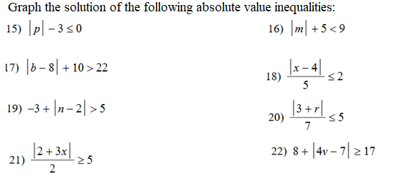

**1. Find the first 5 terms determined by the following recursion formulas.**

**a)  d) **

** **

1. ** e) **

** **

1. ** f) **

** **

**2. Find a recursive formula for each of the following sequences.**

1. ** c) **
2. ** d) **