Questions 1-21 are Multiple Choice

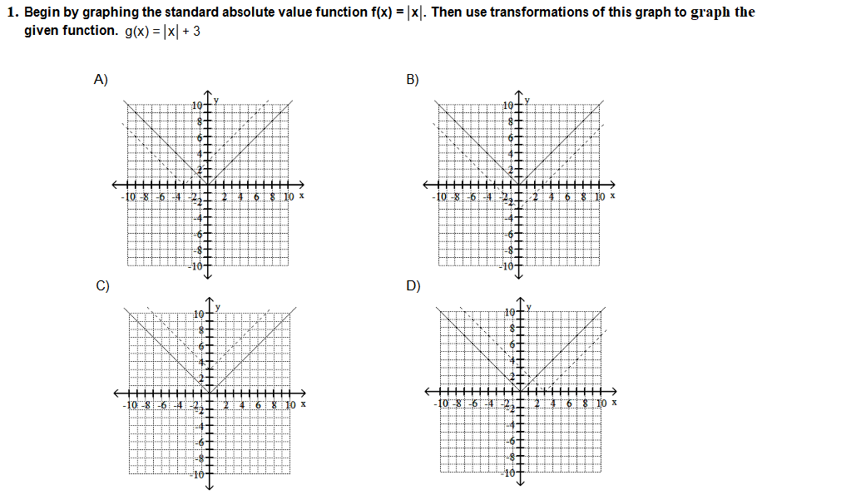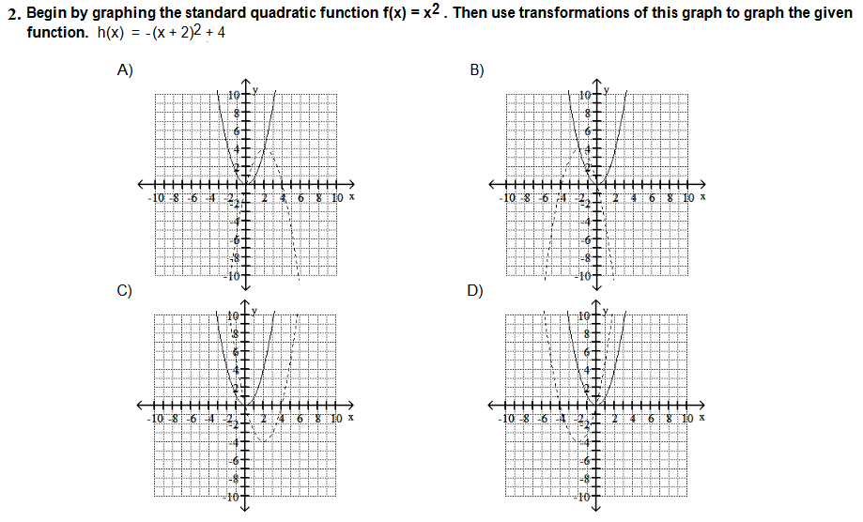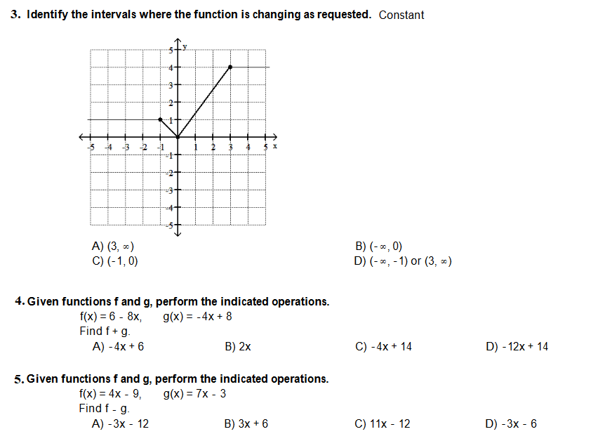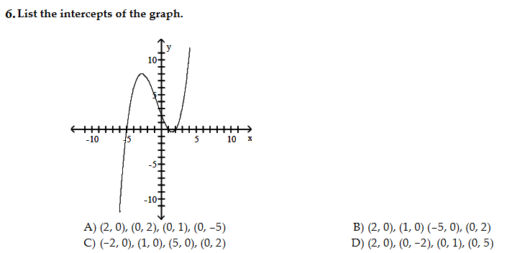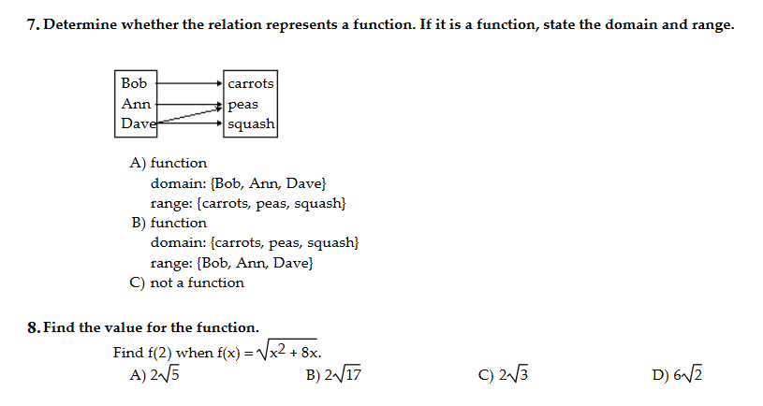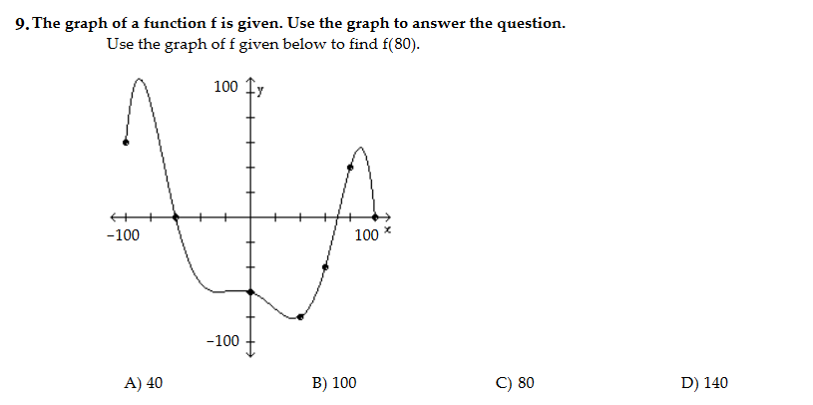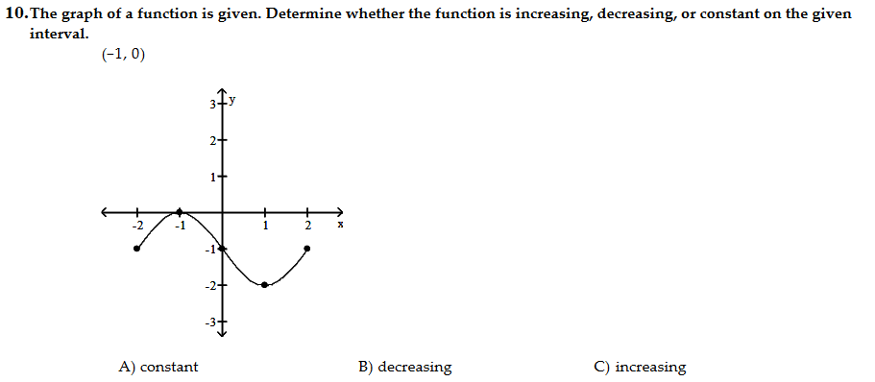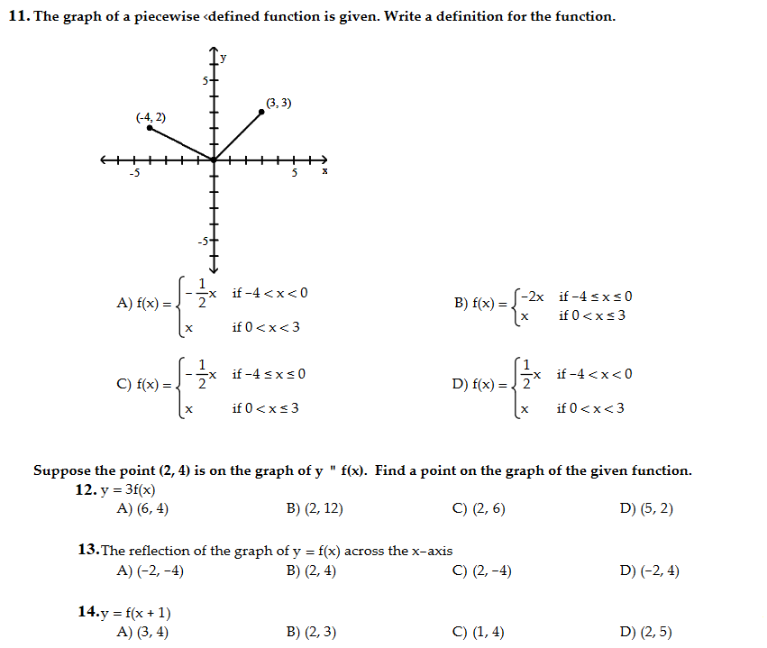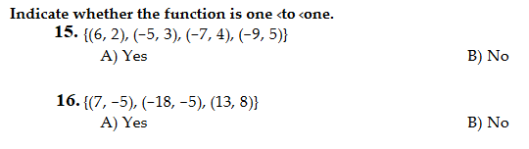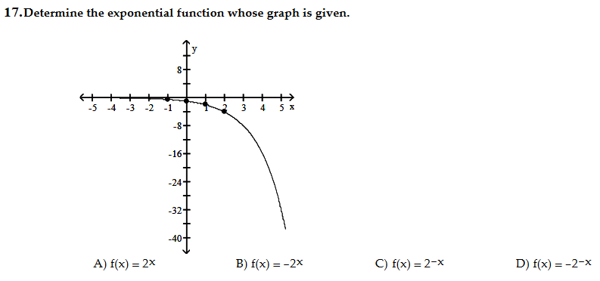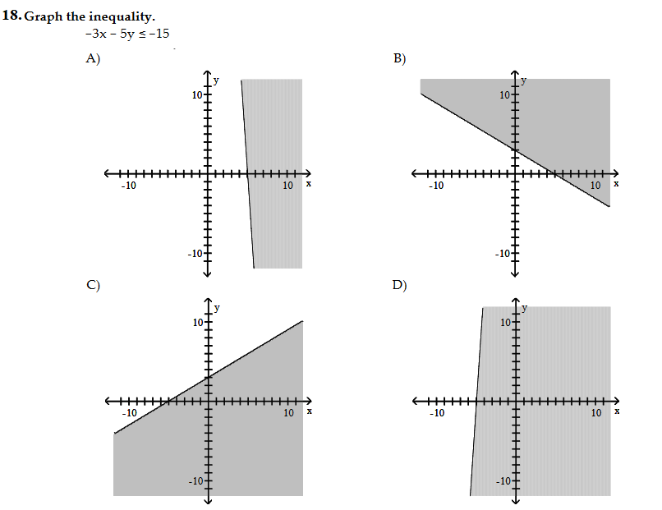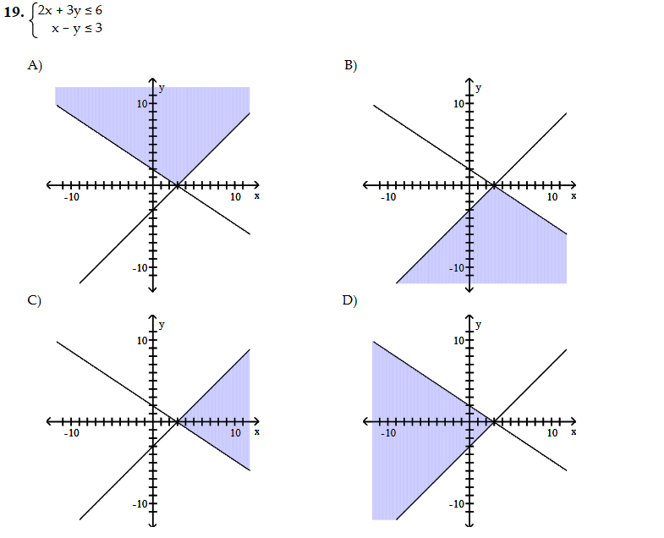
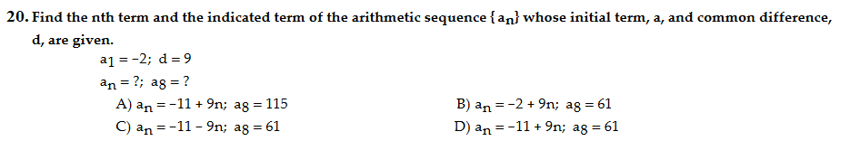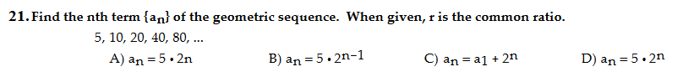
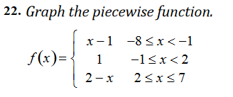
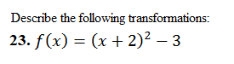

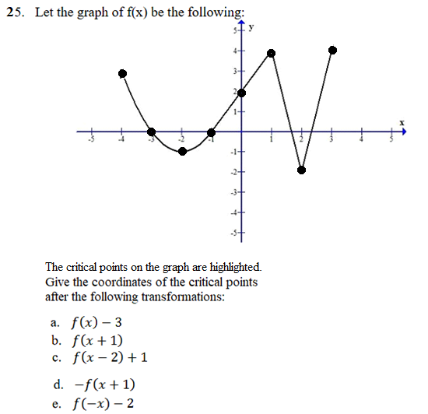


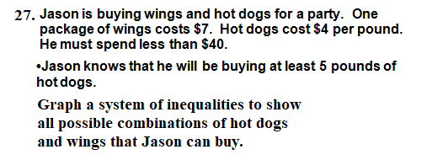
28. A mountain in Butler County is eroding and losing elevation at a rate of 5% every millennium. If the current elevation is 1,200 meters, how tall will the mountain be in 9 millennia?
If necessary, round your answer to the nearest whole number.

29. You have 96 grams of a radioactive kind of tellurium. How much will be left after 3 hours if its half-life is 1 hour?
30. There is a population of 15,000 bacteria in a colony. If the number of bacteria doubles every 300 minutes, what will the population be 600 minutes from now?
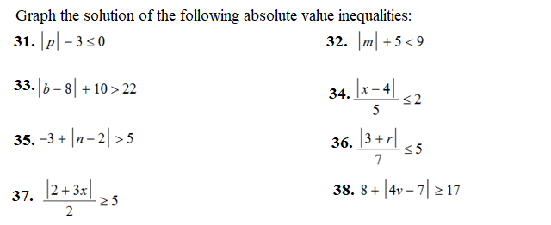
39. Find the first 5 terms determined by the following recursion formulas.

a) 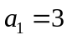 d) 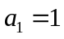
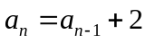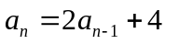

- e) 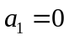
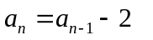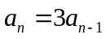

- 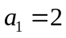 f) 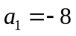
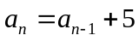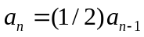

40. Find a recursive formula for each of the following sequences.

- 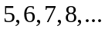 c) 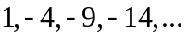

- 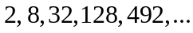 d) 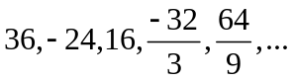
SOLUTIONS
- C
- B
- D
- D
- D
- B
- C
- A
- A
- B
- C
- B
- C
- C
- A
- A
- B
- C
- D
- D
- B
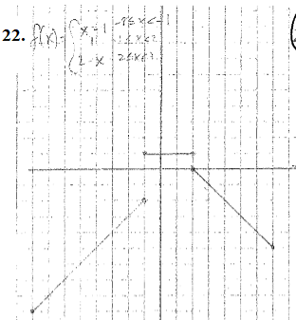
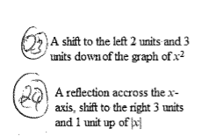
25. (a) (-4,0) (-3,-3) (-2,-4) (-1,-3) (0,-1) (1,1) (2,-5) (3,1)
(b) (-5,-3) (-4,0) (-3,-1) (-2,0) (-1,2) (0,4) (1,-2) (2,4)
(c) (-2,-2) (-1,1) (0,0) (1,1) (2,3) (3,5) (4,-1) (5,5)
(d) (-5,-3) (-4,0) (-3,-1) (-2,0) (-1,-2) (0,-4) (1,2) (2,-4)
(e) (4,1) (3,-2) (2,-3) (1,-2) (0,0) (-1,2) (-2,-4) (-3,2)
26.


