**Algebra I November 16th Review Sheet**

*Absolute Value Inequalities/Compound Inequalities*

1. Solve each inequality. Graph the solution
2. |*j*| – 2 ≥ 6
3. 3
4. -2|3*j*| - 8 ≤ -20
5. Write and solve an absolute value inequality that represents the situation:

Leona was in a golf tournament last week. All four of her rounds of golf were within 2 strokes of par. If par was 72, find the range of scores that Leona could have shot.

*The graph of a situation*

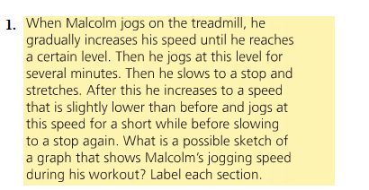

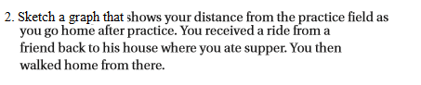

*Piecewise Functions*

Given $f\left(x\right)=\left\{\begin{aligned}x+2,x≤0 \\ x^{3},0<x<2 \\ 9,x≥2\end{aligned}\right.$,

1. find *f*(6) – *f*(1) + *f*(-4)
2. graph the function

*Real-World Exponential Functions*

1. You have 10 CDs. That number doubles every year. (a) Write an equation to model the situation. (b) How many CD’s will you have after 7 years?
2. A town with a population of 5,000 grows 3% per year. (a) Write an equation to model the situation. (b) Find the population at the end of 10 years.
3. The price of a bicycle is $100. The value depreciates 8% per year. (a) Write an equation to model the situation. (b) How much will it be worth after 5 years?
4. The half-life of a proton is 6 months. How much of a 60 gram sample of the proton will be left after 2 years?

*Intervals on Graphs*

**

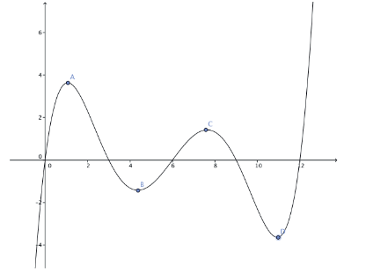

*Recursive Formulas*

1. Given the recursive formula *tn* = *tn* – 1 – 6, *t*1 = 0, find *t*4.



*Calculating Tax*

1. Compute the Federal Income Tax in 2013 for a married couple with 1 children making $100,800.

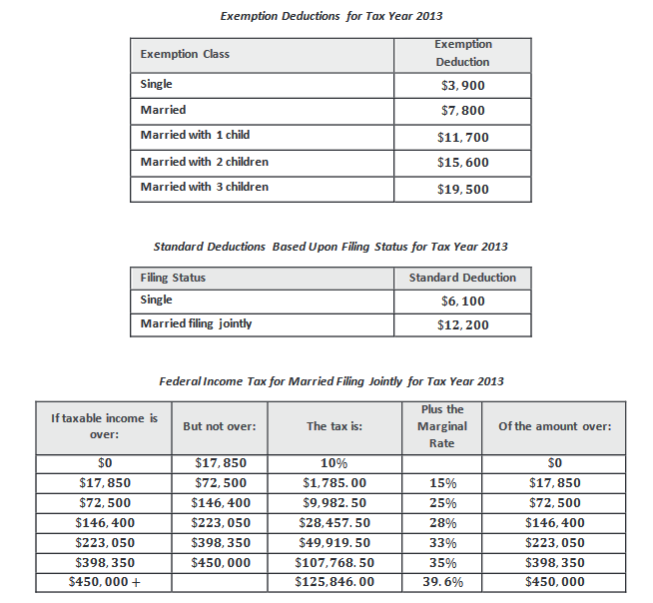

*Parallel and perpendicular lines*

Use the map to answer the following. Show your work.

**a.** City contractors would like to build a library on a road that is parallel to Hope Road at the

indicated spot. They will call that street Peach Street. What is the equation on Peach Street?

**b.** City contractors would like to build a gym on a road that is perpendicular to Elm Street at the

indicated spot. They will call that street Power Street. What is the equation on Power Street?

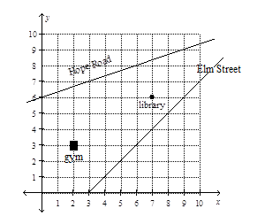

*Multiplying Polynomials*

Simplify (*x + y*)(2*x* – 5*y* + 2)

*Function Notation*

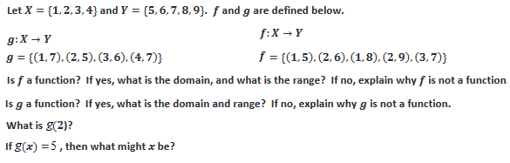

*Compound Interest*

Suppose you invest $1500 in an account paying 4.75% annual interest. Find the account balance after 25 years with the interest compounded quarterly.

*Sequences*

1. Write an equation to represent the sequence 3, 9, 27, … Find the 10th term.
2. Write an equation to represent the sequence 0, 9, 18, … Find the 6th term.

*Relations vs. functions*

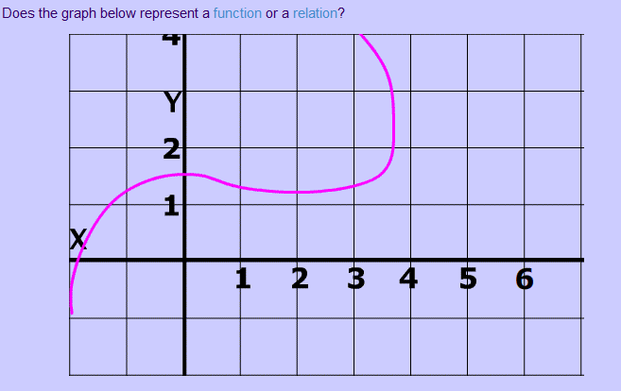 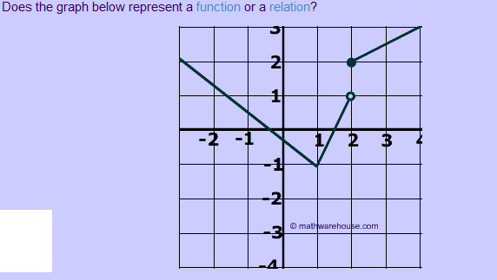

*Exponential vs. Linear*

For Eureka Module 3 Lesson 14 Example 3, **change 1920 to 1915 and 3554 to 3100** and round to the nearest hundredth if necessary.

Solutions

*Absolute Value Inequalities/Compound Inequalities*

1. (a) |*j*| ≥ 8

*j*  ≥ 8 OR *j* ≤ -8; GRAPH

(b) 2 > |*v* + 2|

|*v* + 2| < 2

-2 < *v* + 2 < 2

-4 < *v* < 0; GRAPH

1. -2|3*j*| ≤ -12

|3*j*| > 6

3*j* > 6 OR 3*j* < -6

*j* > 2 OR *j* < -2

1. |*S* – 72| < 2

-2 < *S* – 72 < 2

70 < *S* < 74

*The graph of a situation*

1.

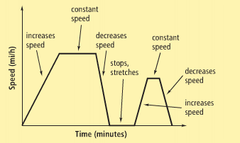

2.

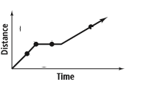

*Piecewise Functions*

1. *f*(6) will be evaluated using piece 3…*f*(6) = 9

*f*(1) will be evaluated using piece 2…*f*(1) = (1)3

= 1

*f*(-4) will be evaluated using piece 1…*f*(-4) = (-4) + 2

= -2

So *f*(6) – *f*(1) + *f*(-4) = 9 – 1 + (-2)

= 6

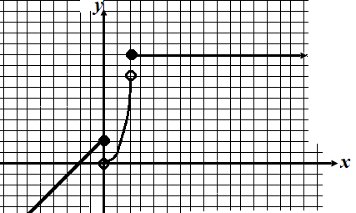

*Real-World Exponential Functions*

1. (a) *G*(*n*) = 10(2)*n*, *n* ≥ 0 (b) The 7th year is the 8th term in the sequence: *G*(8) = 2560
2. A town with a population of 5,000 grows 3% per year. (a) *y* = 5000(1.03)*x* (b) *y* = 5000(1.03)10, 6720 people (or 6719)
3. The price of a bicycle is $100. The value depreciates 8% per year. (a) *y* = 100(0.92)*x* (b) *y* = 100(0.92)5, $65.91
4. After 6 months 60 $÷$ 2 = 30g, after 1 year 30 $÷$ 2 = 15g, after 1.5 years 15 $÷$ 2 = 7.5g, after 2 years 7.5 $÷$ 2 = 3.75g.

*Intervals on Graphs*

Increasing when *x* is between ≈ -.05 and ≈1, ≈ 4.1 and ≈7.6, ≈11 and ≈12.5

Decreasing when *x* is between ≈1 and ≈4.1, ≈7.6 and ≈11

Positive when *x* is between 0 and ≈3, 6 and ≈9, 12 and ≈12.5

Negative when *x* is between ≈-0.5 and 0, ≈3 and 6, ≈9 and 12

*y*-intercept (0,0)

*x*-intercepts (0,0), (3,0), (6,0), (≈9,0), (12,0)

*Recursive Formulas*

1. *t*2 = *t*2 – 1 – 6

*=* *t*1 – 6

*=* 0 – 6

= -6

*t*3 = *t*3 – 1 – 6

*=* *t*2 – 6

*=* -6 – 6

= -12

*t*4 = *t*4 – 1 – 6

*=* *t*3 – 6

*=* -12 – 6

= -18

1. (a) A (b) D

*Calculating Tax*

1. Taxable Income = $100,800 – 11700 – 12200

= 76900

Row 3 says tax = 9982.50 + 25% of income over 72,500

= 9982.50 + 0.25(76900 – 72500)

= $11082.50

*Parallel and perpendicular lines*

**a.** Slope of Hope = ⅓, Slope of road = ⅓

Point (7,6)

*y* = ⅓*x + b*

6 = ⅓(7) + *b*

*b* = 11

3

*y* = ⅓*x* + 11

3

**b.** Slope of Elm = 1, Slope of road = -1

Point (2,3)

*y* = -*x + b*

3 = -1(2) + *b*

*b* = 5

*y* = -*x* + 5

*Multiplying Polynomials*

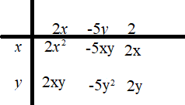

(*x + y*)(2*x* – 5*y* + 2) = 2*x*2 – 5*y*2 – 3*xy* + 2*x* + 2*y*

*Function Notation*

*f* is not a function because it is not one to one

*g* is a function, *D* = {1,2,3,4}, *R* = {5,6,7}

*g*(2) = 5

*x* = 2

*Compound Interest*

$4884.02

*Sequences*

1. *G*(*n*) = 3(3)*n*, *n* ≥ 0 OR *G*(*n*) = 3(3)*n -* 1, *n* ≥ 1;

tenth term is

*G*(9) = 59049 OR *G*(10) = 59049

1. *A*(*n*) = 9(*n* – 1), *n* ≥ 1 OR *A*(*n*) = 9*n*, *n* ≥ 0

6th term is

*A*(6) = 45 OR *A*(5) = 45

*Relations vs. functions*

Left graph fails vertical line test so it is not a function

Right graph passes vertical line test so it is a function

*Exponential vs. Linear*

(0, 1490) and (15, 3100) and the coordinates

Slope = 3100 – 1490

15 – 0

= 107.3

1. *f*(*x*) = 107.33*x* + 1490
2. *g*(*x*) *=* 1490(1.05)*x*

|  |  |  |
| --- | --- | --- |
|  | *f*(*x*) | *g*(*x*) |
| 1935 | 5247 | 8219 |
| 1960 | 7930 | 27832 |
| 2010 | 13296 | 319161 |

1. Exponential
2. Neither