ALGEBRA I EXAM 2.1 Part I
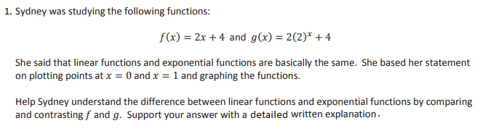(3 points)
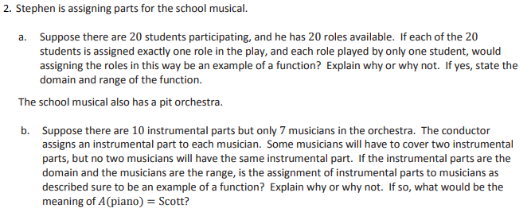
(7 points)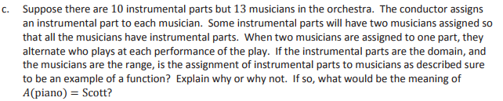
(2 points)
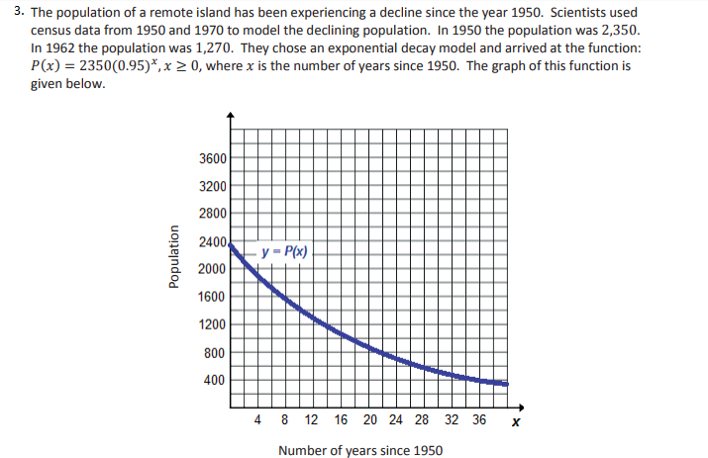
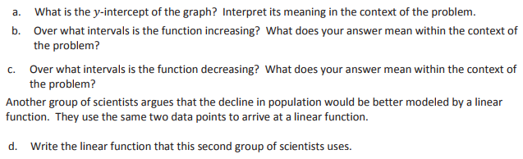
(8 points)
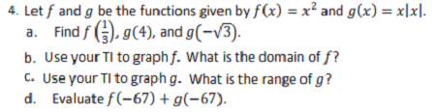
(6 points)
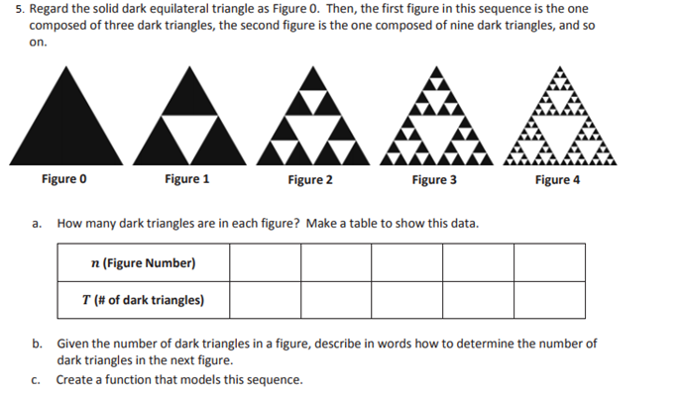
(5 points)
6. a. Graph the relation given by $p\left(x\right)=\left\{\begin{aligned}x,x≤-1 \\ -1,-1<x<0 \\ x-1,0≤x≤2 \\ -x+3,x>2\end{aligned}\right.$ (4 points)
b. Is p(x) a function? (1 point)
c. Evaluate p(3) + p(2) – p(-5) (2 points)

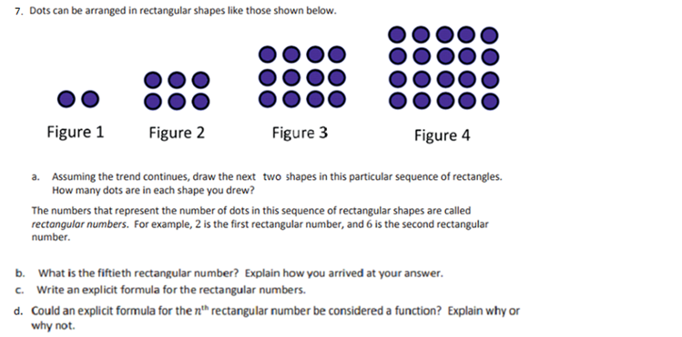
(8 points)
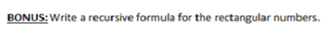
(2 points)

